Name:
Date:
Period/Teacher:

This Is My Earth: Introduction Activity

Learning Objectives: What are you going to learn?
↓Fill in the blanks below↓
- I will be able to define _____________ and describe what makes a particular area a biodiversity __________.
- I will be able to discuss the ____________________ and ___________________ to biodiversity conservation.
- I will be able to develop and ______________________________ in favor of preserving a particular biodiversity hotspot through the TiME organization.

Video: What is biodiversity?
↓Write 3 interesting facts from the video in the boxes below↓

… Biodiversity
↓Write the definition below↓
Biodiversity is the ___________________________________________________________

_____________________________________________________________________________

Why are we losing species?
↓List and define the reasons below↓
- ________________________ | The process by which a natural habitat becomes ______________  _______________________________  Its native species.
- ________________________ | Continuous habitat broken up into many _____________________, so areas are ___________________  __________________________ by a human-made matrix of different land use types
- ________________________ | The ____________________________ of natural resources and ______________ of wild animal and plant species by people.  Example:
- ________________________ | Significant changes in __________  _______________________________, precipitation, wind patterns and other measures of climate that occur over several decades or longer.

Fill in the blanks in the feedback loops below:

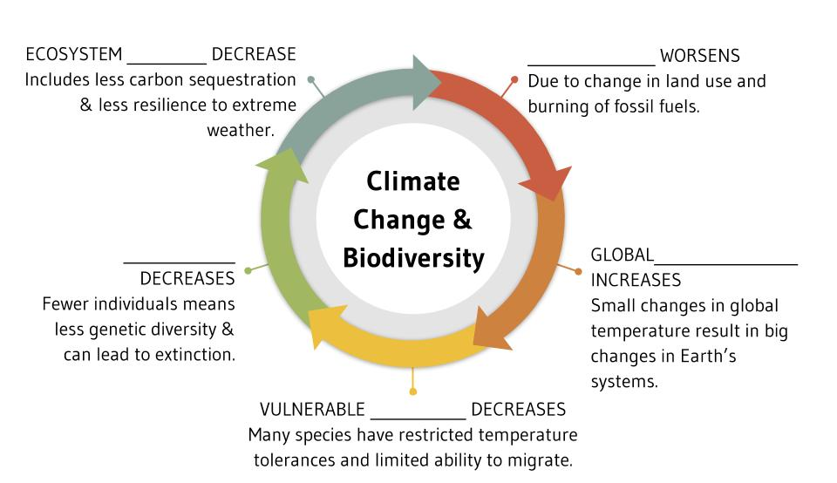
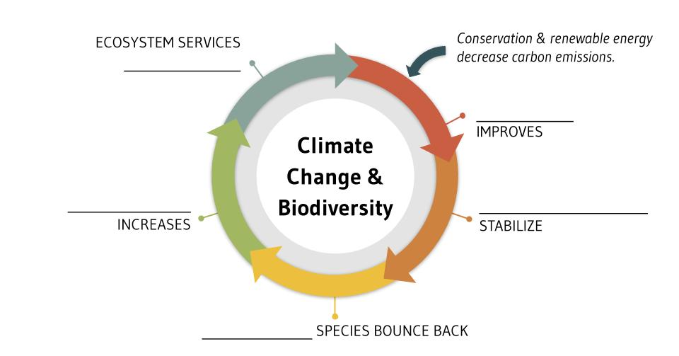

_____________________ Species | Species that are _______________ to a single defined geographic location (such as an island) or habitat type found _____________  _________________ in the world.

Biodiversity hotspots
Represent just________% of Earth’s land surface
Support more than __________% the world’s endemic plant species
Support nearly ________% of endemic bird, mammal, reptile and amphibian species.
To qualify as a biodiversity hotspot, a region must meet two strict criteria:
(You may write these in your own words)

- It must have ______________________________________________________

- It must have ________________________________________________________

Problem: Over ______% of biodiversity hotspots are ________________  ______________. | Solution: __________________________

